SPRING REST USING SPRING BOOT

Name : Shubham Sangram Bej

Objective
The objective of this hands-on is to understand the implementation of RESTful Web Services using Spring Boot. The application demonstrates REST controllers, Spring Bean configuration using XML, dependency injection, exception handling, logging, and unit testing.

Software Requirements
- Java Development Kit (JDK 21)
- IntelliJ IDEA 2026.1.4
- Spring Boot 4.1.0 (May also use 3.x versions, but they are no longer available on Intellij)
- Maven
- Git
- GitHub

Exercise 1 – Hello World REST Service

Objective
To create a Spring Boot REST application and expose a simple REST endpoint.

Implementation
- Created a Spring Boot project.
- Configured the application.
- Implemented a REST controller.
- Verified the endpoint using a web browser.

Endpoint
GET /hello (or) http://localhost:8083/hello

Output
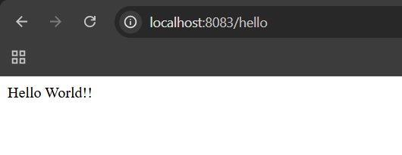

Exercise 2 – Country Bean using XML Configuration

Objective
To configure Spring Beans using XML configuration and expose the bean through a REST API.

Implementation
- Created the Country class.
- Configured Country Bean inside country.xml.
- Loaded the bean using Spring ApplicationContext.
- Returned the Country object through REST API.

Endpoint
GET /country (or) http://localhost:8083/country

Output
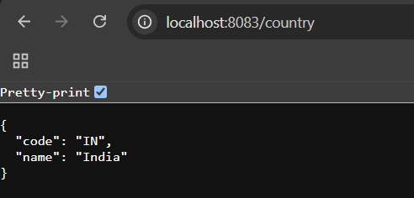

Exercise 3 – Display List of Countries

Objective
To configure multiple Country Beans and return them as a collection.

Implementation
- Configured multiple Country beans.
- Created a List containing all Country objects.
- Returned the complete list through REST API.

Endpoint
GET /countries (or) http://localhost:8083/countries

Output
Returns all configured countries.
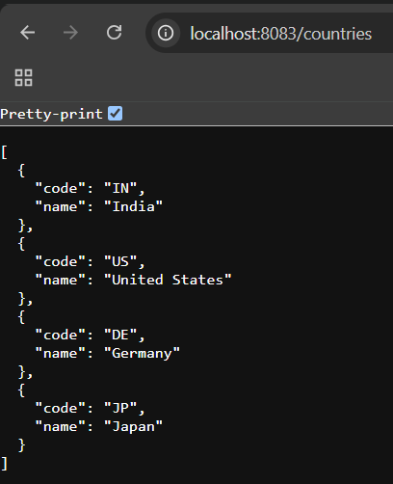

Exercise 4 – Search Country by Country Code

Objective
To retrieve a Country object based on the supplied Country Code.

Implementation
- Implemented search functionality.
- Compared the requested Country Code with available Country objects.
- Returned the matching Country.

Endpoint
GET /countries/{code}

Example
GET /countries/in or http://localhost:8083/countries/in
GET /countries/JP or http://localhost:8083/countries/JP

Output
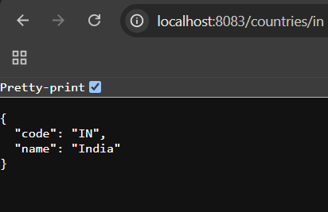
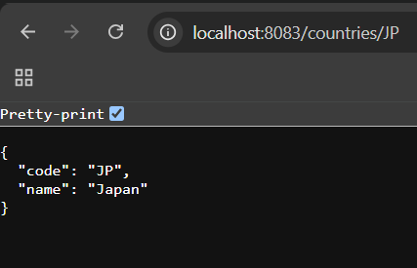

Exercise 5 – Exception Handling

Objective
To implement custom exception handling for invalid Country Codes.

Implementation
- Created a custom exception class.
- Returned an appropriate HTTP error response whenever an invalid Country Code is requested.

Example
GET /countries/az (or) http://localhost:8083/countries/az

Output
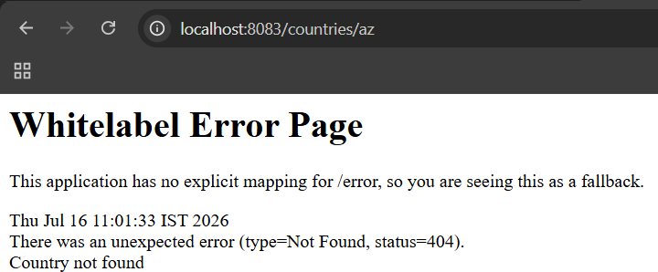

Exercise 6 – Unit Testing

Objective
To verify the application functionality using Spring Boot testing.

Implementation
The following test cases were executed successfully:
- Application Context Loading
- Country REST Endpoint Validation
- REST Response Verification

Result
All test cases executed successfully.
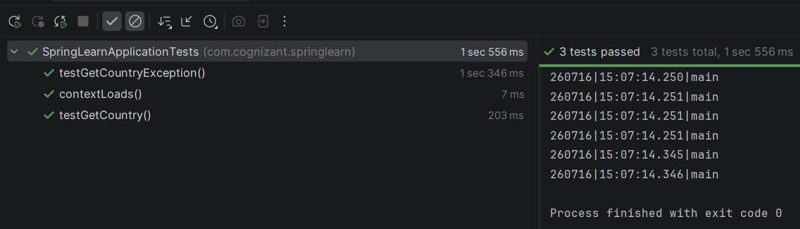

Conclusion
The objectives of the "Spring REST Using Spring Boot" hands-on were successfully achieved. The REST APIs were developed, tested, and verified successfully. Spring XML configuration, dependency injection, exception handling, and testing were implemented as per the requirements. The project was successfully executed and version-controlled using Git.

